Solar cell equivalent circuit
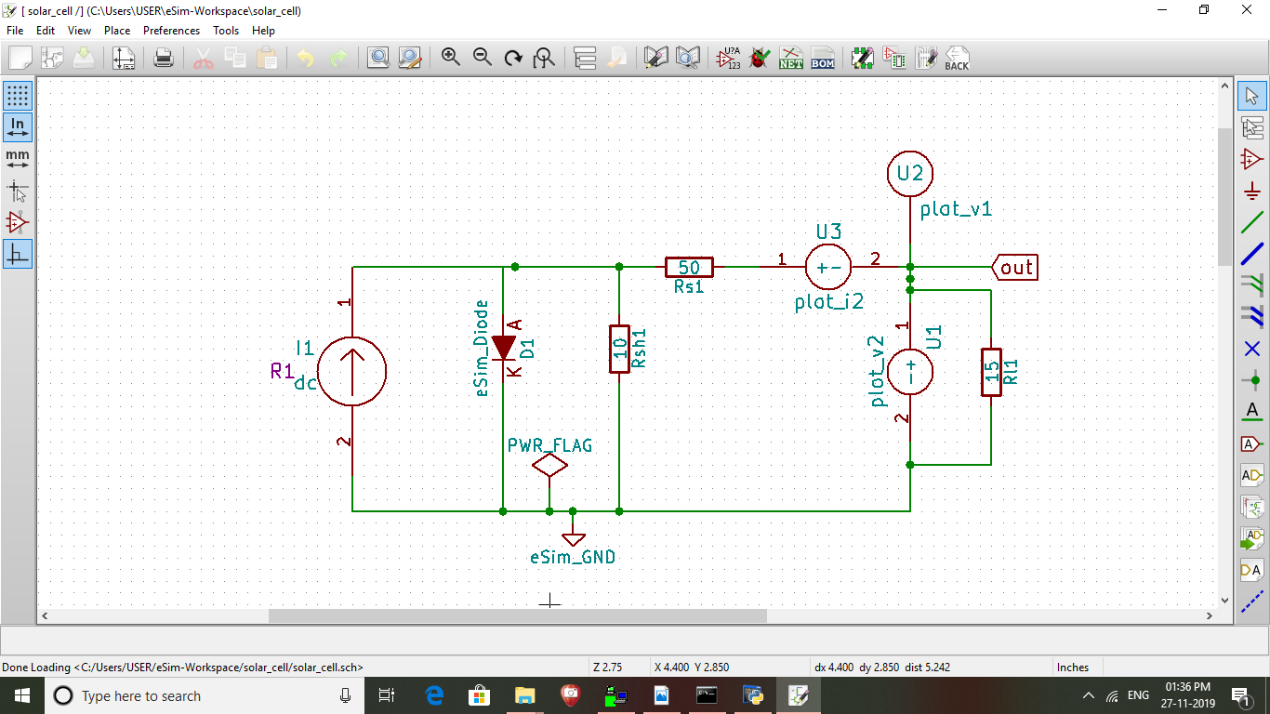
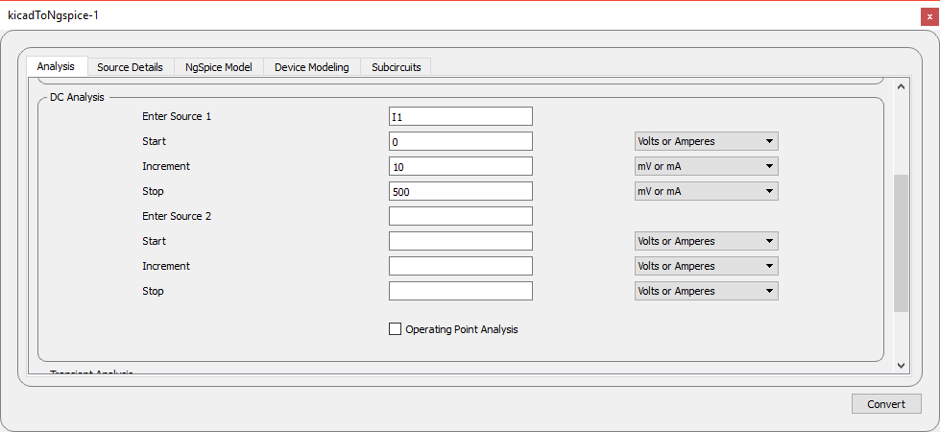
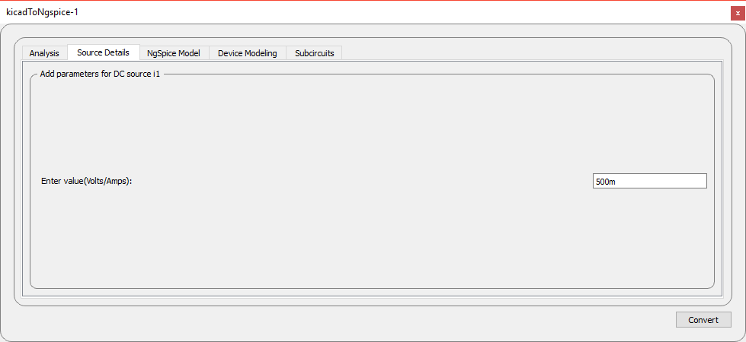
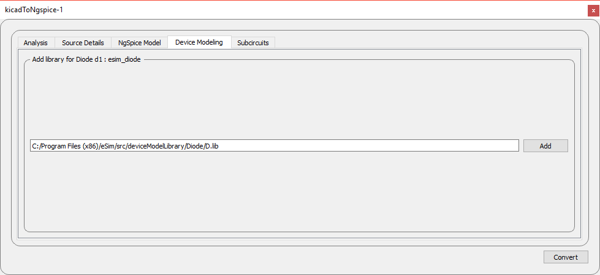
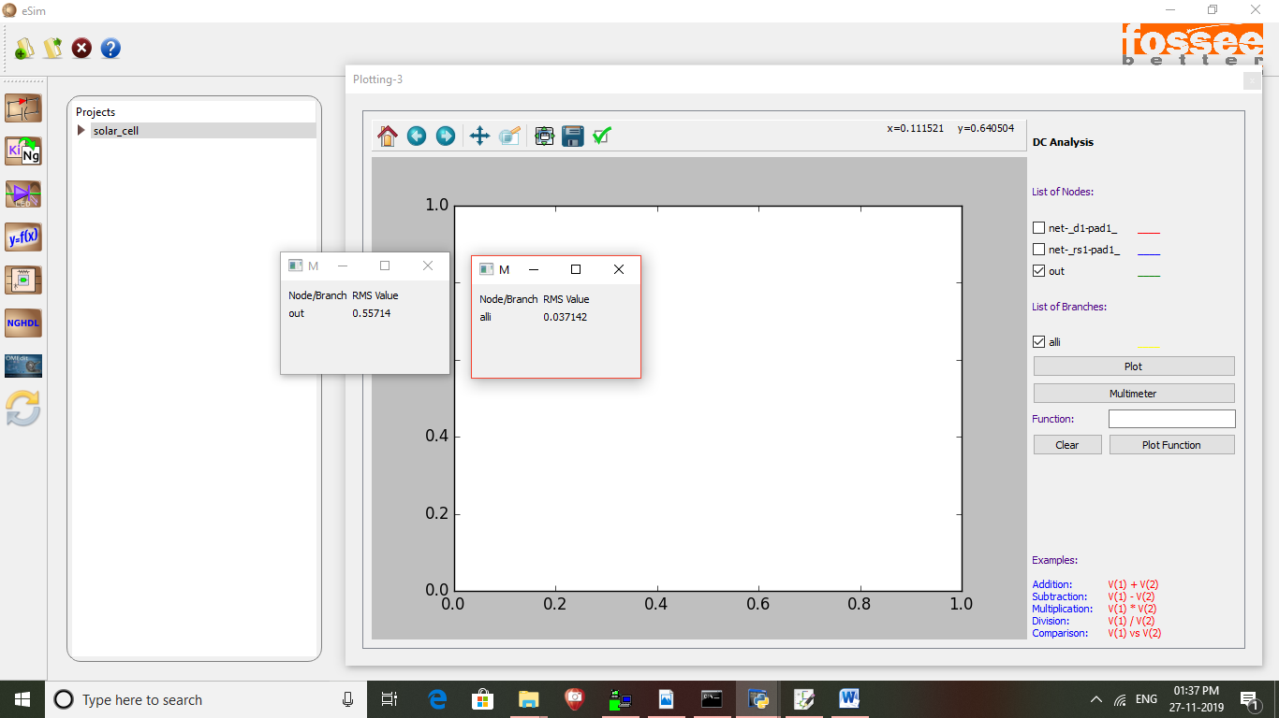
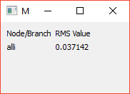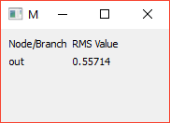
IV characteristics graph
5 | 0.21 | 4.285
10 | 0.39 | 3.979
15 | 0.55 | 3.714
20 | 0.69 | 3.482
25 | 0.81 | 3.277
30 | 0.92 | 3.095
35 | 1.02 | 2.932
40 | 1.11 | 2.785
45 | 1.19 | 2.653
50 | 1.26 | 2.532
100 | 1.74 | 1.741
200 | 2.14 | 1.071
300 | 2.32 | 0.773
400 | 2.42 | 0.605
500 | 2.48 | 0.497
600 | 2.53 | 0.422
700 | 2.56 | 0.366
800 | 2.59 | 0.323
900 | 2.61 | 0.29

