Differences in toolbars icons between tutorial and my KiCad installation although both are using KiCad version 5.0.2. Here are two screen shots each to compare:
Screen shot 1: Tutor’s footprint editor tool bar
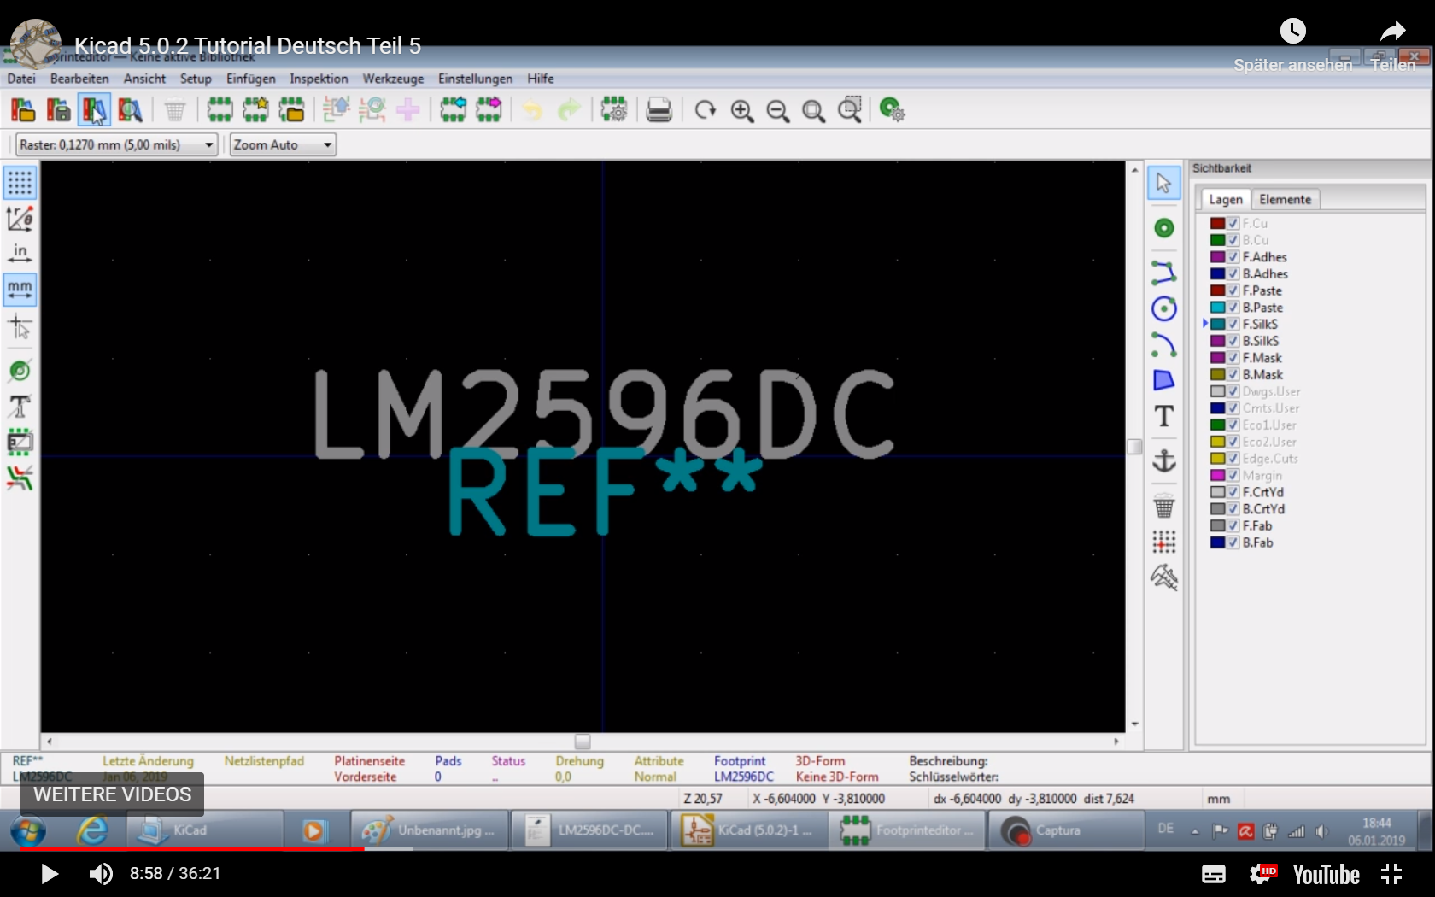
Screen shot 2: My footprint editor tool bar
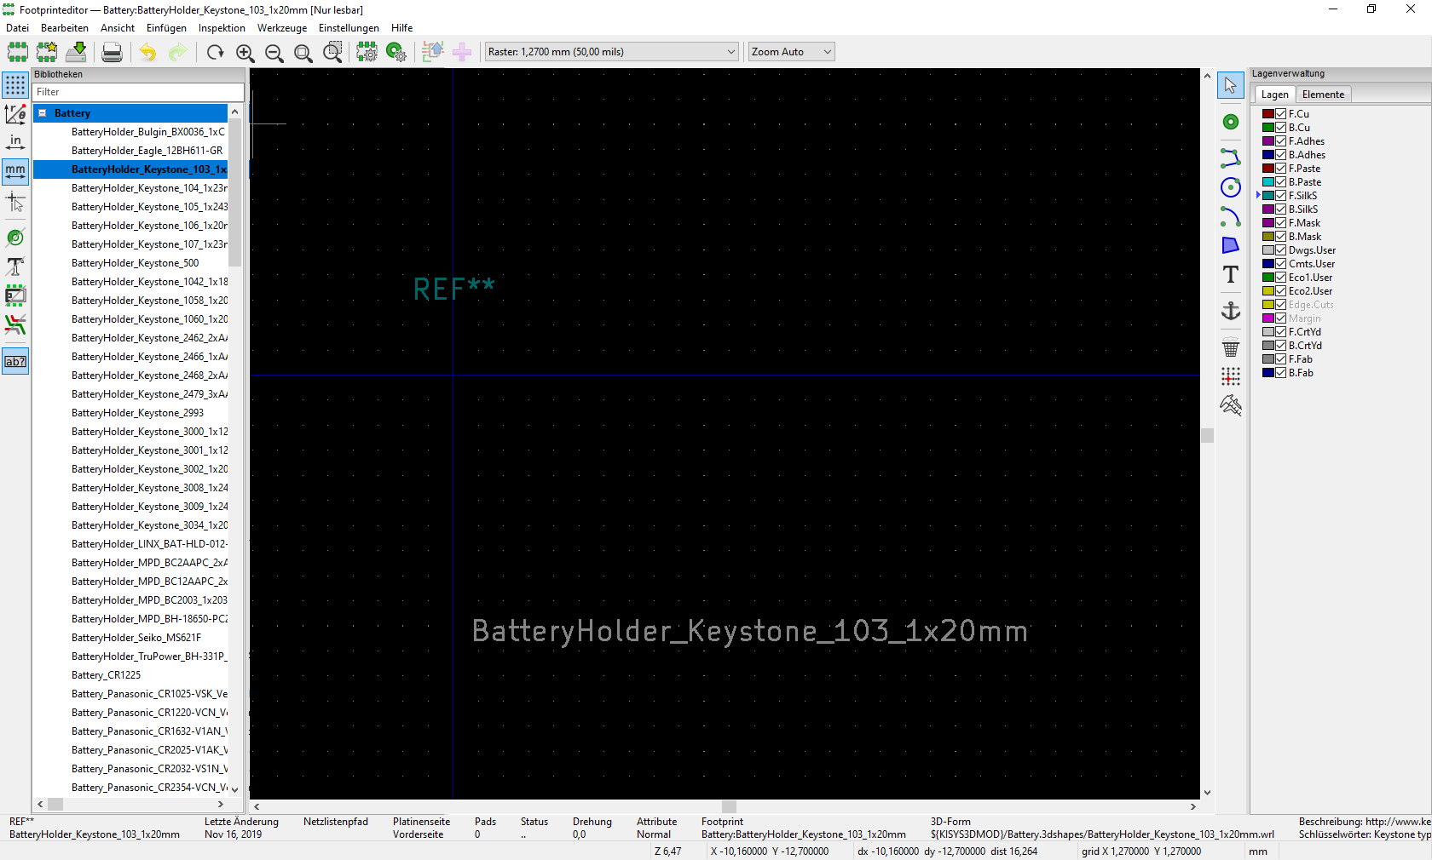
Screen shot 3: Tutor’s component editor tool bar
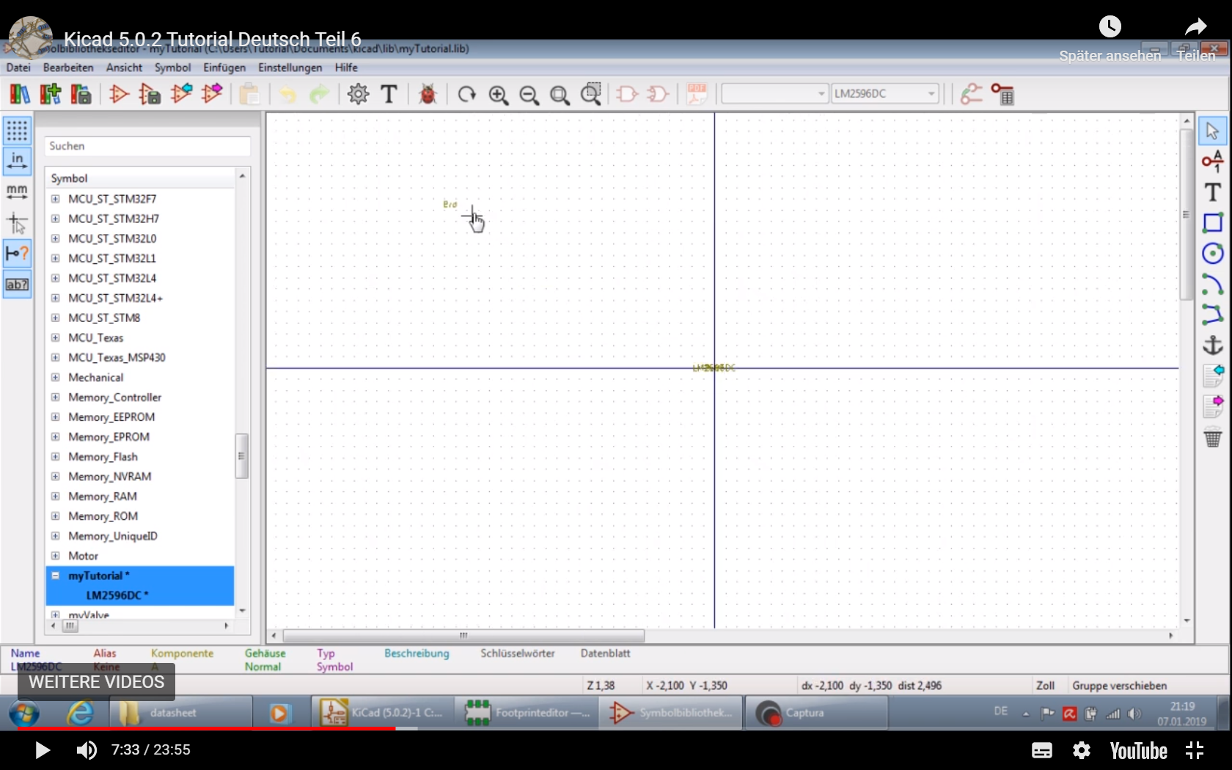
Screen shot 4: My component editor screen tool bar
