PJ-102AH Barrel jack 3D model (in KiCad 3D lib (?)
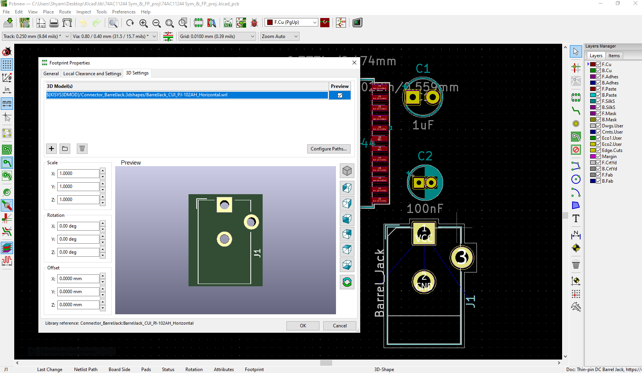
PJ-102AH barrel jack 3D model (step file from external source) overlapping KiCad (?) 3D model
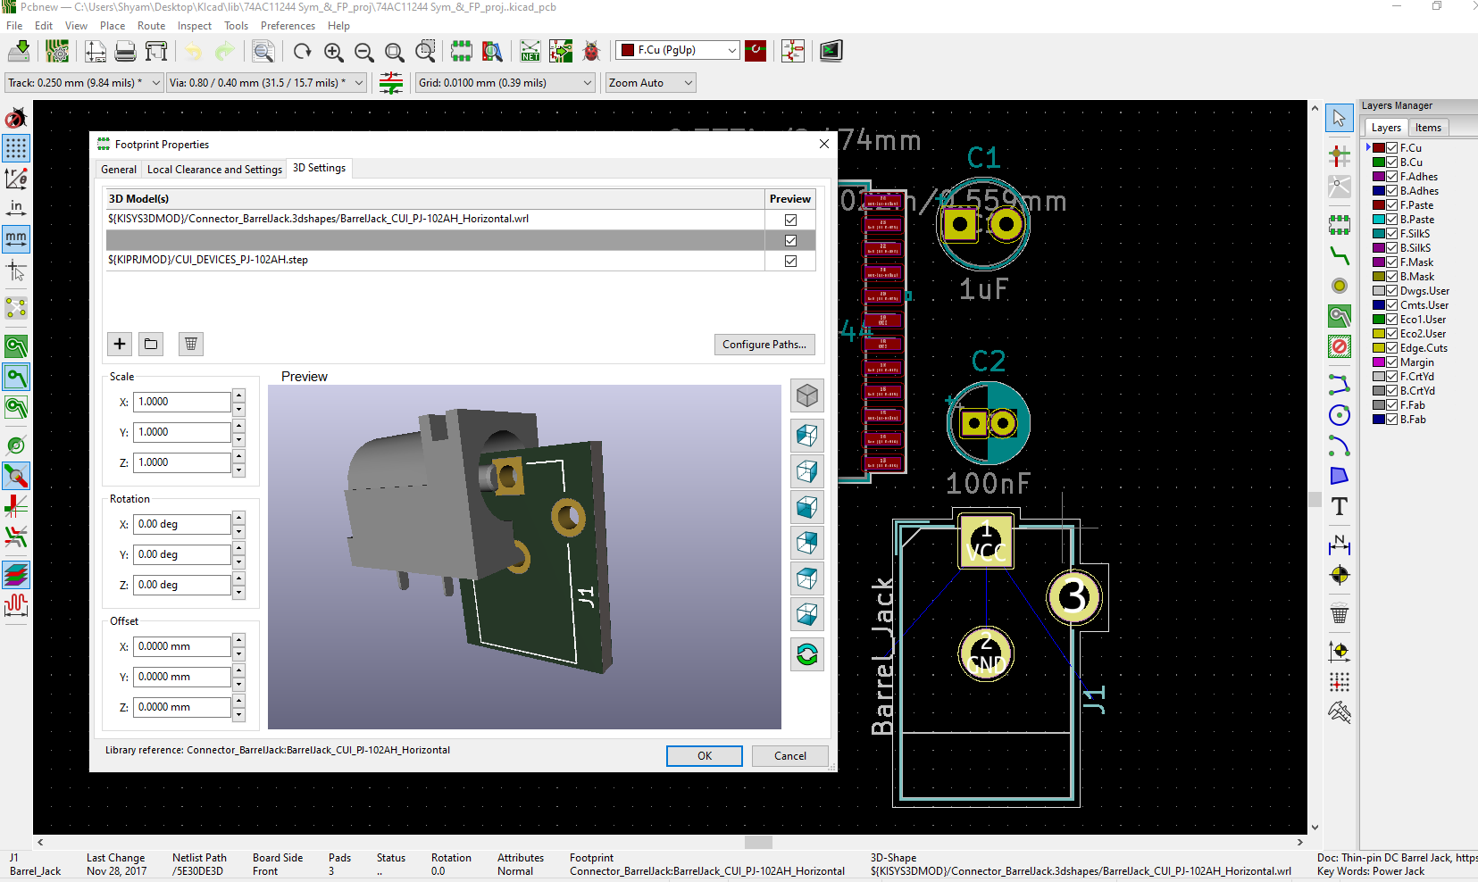
Question: How to remove the KiCad (?) 3D model?

