KiCad Screenshot – Schematic entry:
The symbol 74LS74 consists of sub symbols A, B and C
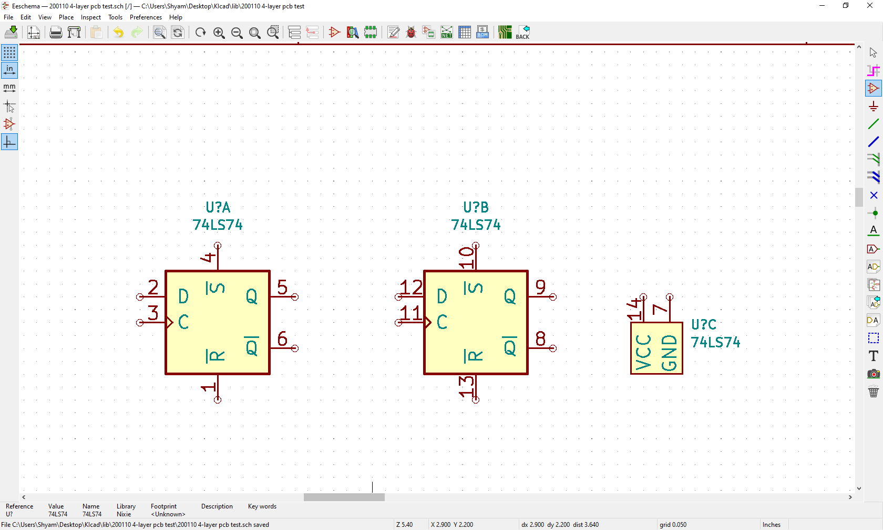

Screen shot: Symbol editor:
While editing only sub symbol A is shown/offered