How to Keep the Same Ref Des When Moving Components from One Sheet to Another in Kicad
Background Information:
- Moving components from one sheet to another in kicad will force you to re-annotate the reference designators on the components you moved.
- When you go to update PCB from schematic, the layout editor will force you to re-place these components with the ref des you changed. NOT IDEAL.
- Here’s how to prevent that issue and maintain the same reference designators:

- Create a new sheet that you would like to move components into. Below is my new sheet I created DO NOT move components into it yet.
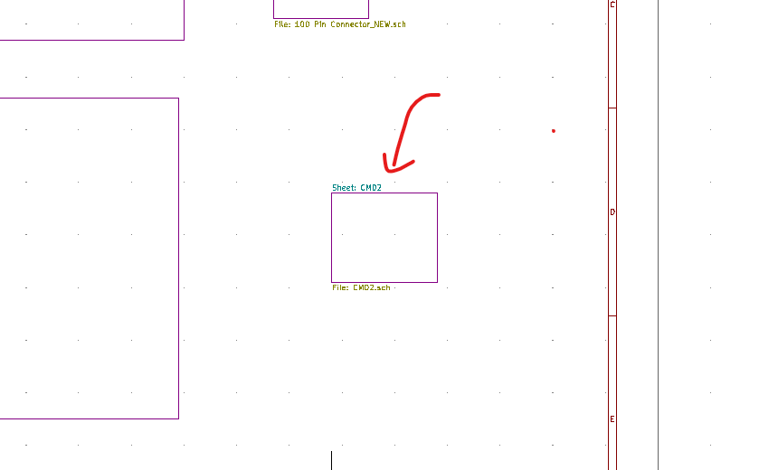
- Go to your project folder and open this new sheet up in Notepad or some other text editor:
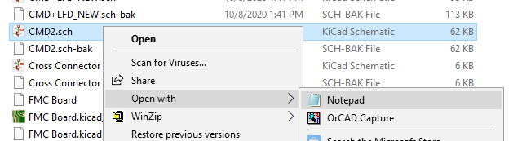

- Open the sheet you would like to copy components from
- Delete the text in step 2s Notepad document:
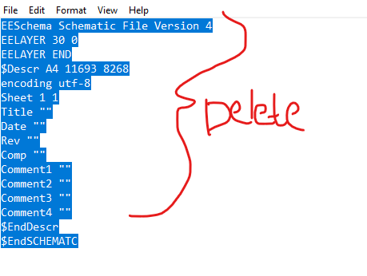
- Copy ALL text from Step 3s Notepad document and paste it into the new sheet you would like to copy to (this is the sheet in step 2).
- Save the notepad document as the same name of the .sch file of the NEW sheet in step 2 in your project file folder. Do not alter the name.
- Go into your schematic and open the new sheet. You will see a copy of all the components in the old sheet. If you are breaking up components on two separate sheets, delete all unwanted components from the new sheet AND the old sheet.
- Save the schematic and open the board layout.
- Go to “Update PCB from schematic.”
- Select this option:
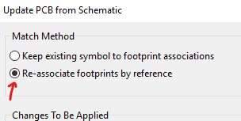

- Check to make sure the reference designators match the component AND signal on that component.

